**Problem Title :**  Modeling a Family Tree in Prolog

**Problem description :**

The objective of this project is to create a Prolog program that models a family tree up to the third generation. The program will define a set of facts and rules to represent various family relationships. The relationships to be modeled include parent, mother, father, siblings, grandparents, aunts/uncles, and cousins. Gender specifications will be included to accurately define relationships.

**Tools and Languages Used :**

* Prolog
* Notepad++ (for writing and testing Prolog code)
* Graphical tool for drawing family tree (draw.io)

**Diagram :**

Here's the tree structure of my family:

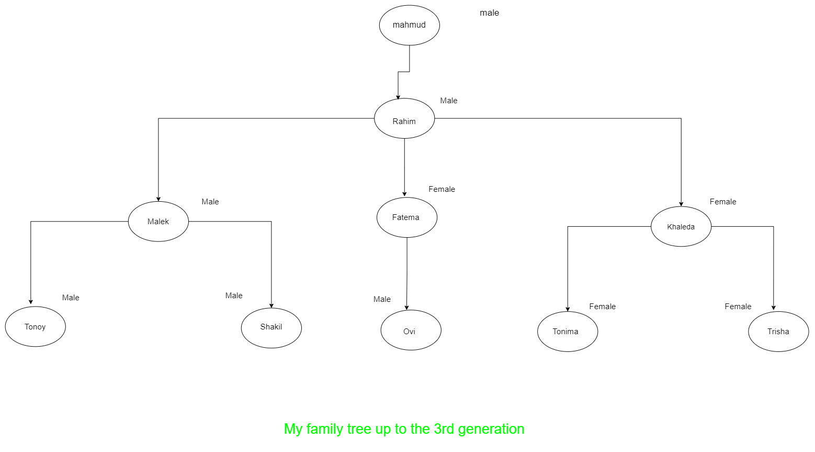

**Prolog Code :**

male(mahmud).

male(rahim).

male(malek).

male(tonoy).

male(shakil).

male(ovi).

female(fatema).

female(khaleda).

female(tonima).

female(trisha).

parents(rahim,malek).

parents(rahim,fatema).

parents(rahim,khaleda).

parents(malek,tonoy).

parents(malek,shakil).

parents(fatema,ovi).

parents(khaleda,tonima).

parents(khaleda,trisha).

father(X,Y):- parents(X,Y),male(X).

mother(X,Y):- parents(X,Y),female(X).

sibling(X,Y):- parents(Z,X),parents(Z,Y),X \== Y.

grandparent(X,Y) :- parents(X,Z), parents(Z,Y).

grandgrandparent(A,B) :- parents(A,X), grandparent(X,B).

uncle(X,Z):-sibling(X,Y),parents(Y,Z),male(X).

aunty(X,Z):-sibling(X,Y),parents(Y,Z),female(X).

cousin(X,Z):-sibling(W,Y),parents(W,X),parents(Y,Z).

**Sample Input/Output :**

**Query :** All child and mother relationship

**Prolog output :**

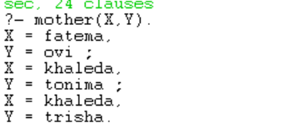

**Query :** what is the name of Tanima's mother?

**Prolog output :**

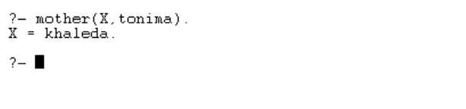

**Query :** All child and father relationship

**Prolog output :**

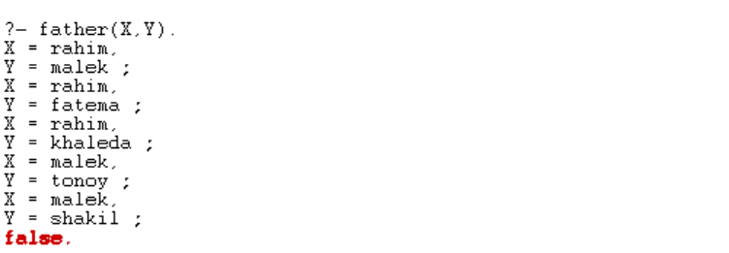

**Query :** what is the name of Tonoy's father?

**Prolog output :**

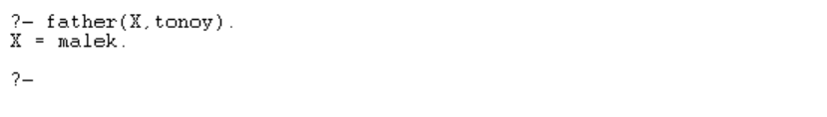

**Query :** All sibling relationship

**Prolog output :**

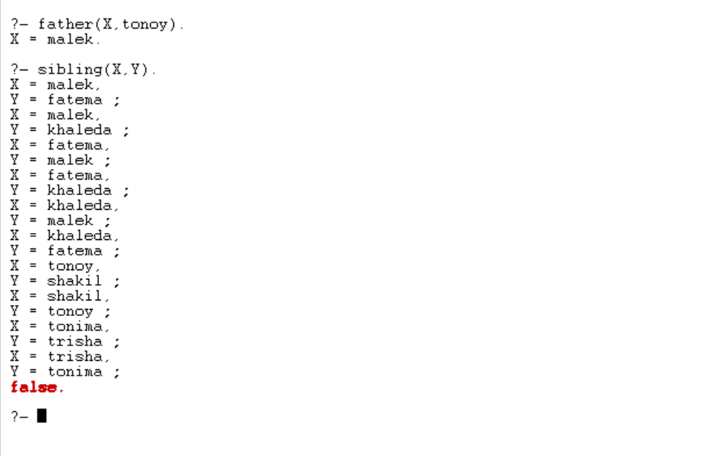

**Query :** who is Tonoy’s siblings?

**Prolog output :**

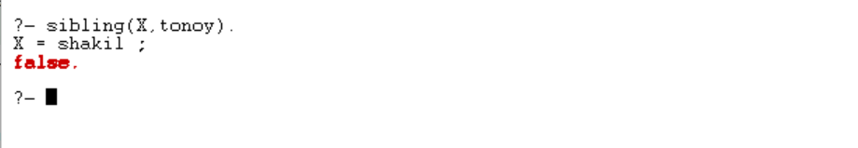

**Query :** who is Tonoy’s grandfather?

**Prolog output :**

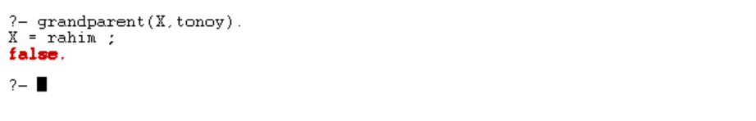

**Query :** is Rahim the grandfather of Ovi?

**Prolog output :**

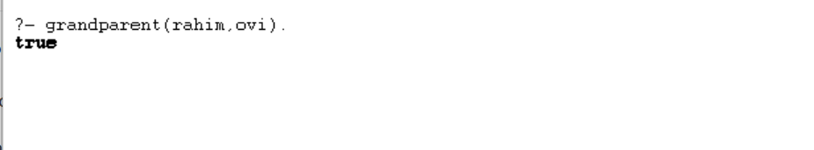

**Query :** all uncle and nephew list?

**Prolog output :**

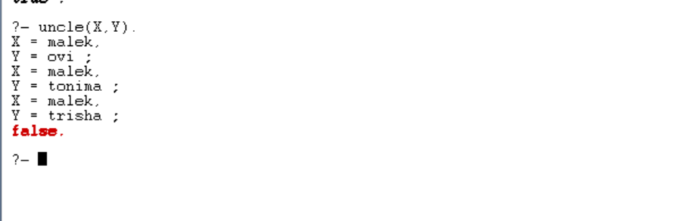

**Query :** who is Trisha’s grandfather?

**Prolog output :**

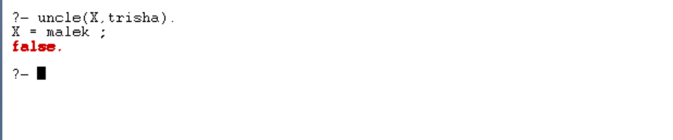

**Query :** is Malek the uncle of Tanima?

**Prolog output :**

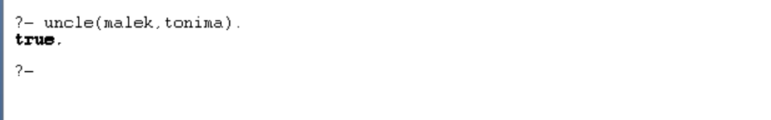

**Query :** Who are Tonoy’s aunty?

**Prolog output :**

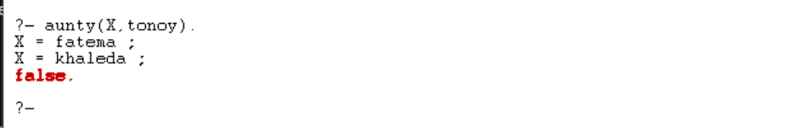

**Query :** Who are Tonoy’s cousins?

**Prolog output :**

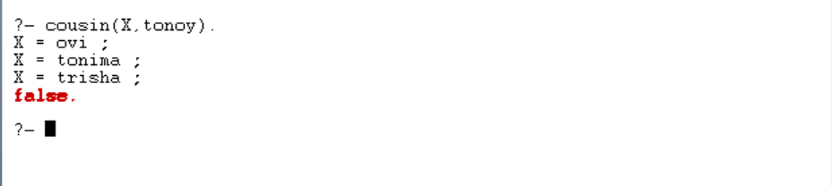

**Query :** all cousins list?

**Prolog output :**

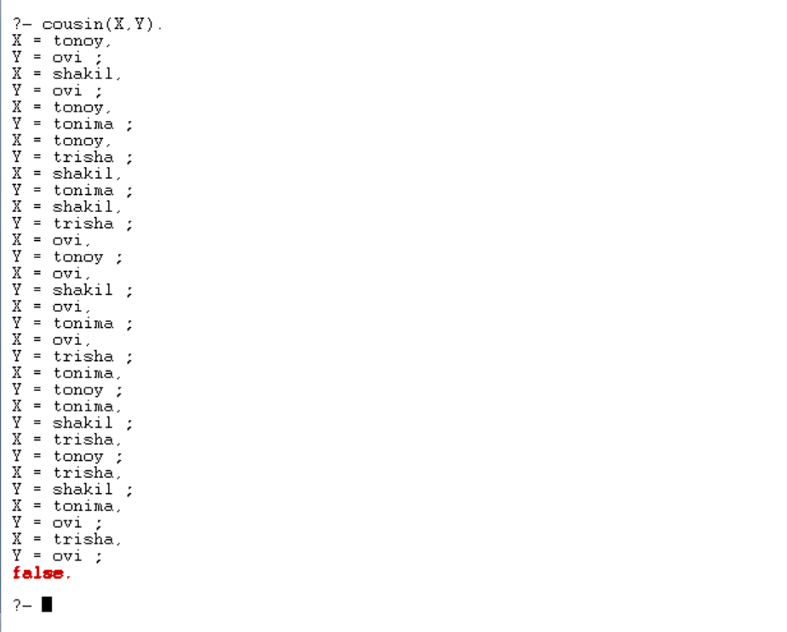

**Query :** List of all male?

**Prolog output :**

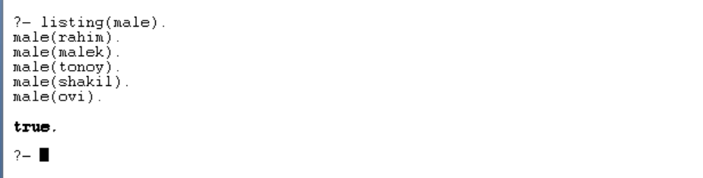

**Query :** List of all female?

**Prolog output :**

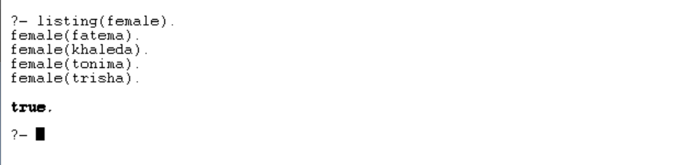

**Query :** who is tonoy grandgrandparent?

**Prolog output :**

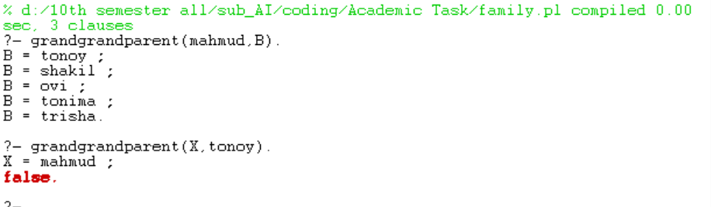

**Conclusion and Challenges :**

This project provided a practical introduction to Prolog and logical programming. Defining family relationships through facts and rules in Prolog was straightforward, but ensuring the correctness of the rules required careful consideration, especially for relationships like cousins and aunts/uncles. The primary challenge was accurately encoding the relationships and ensuring that queries return the expected results. Overall, this exercise has enhanced my understanding of Prolog and logical programming paradigms

**Diagram link :** https://drive.google.com/file/d/1hPveopRmKeJt1BZXQlwcH_OvZyx68OMC/view?usp=sharing

**Name : Salman Johir Tonoy**

**ID : CSE2102023012**

**Subject Name : artificial intelligence**